3.4 I can explain the effectiveness of tests and reflect on their purpose

When testing software it is important to note that no system can ever be 100% bug free. The purpose of tests is to verify that the product meets the requirements of the specification. For example Requirements Analysis is the first step in the V-Model software development process. The requirements of the proposed system are analysed based on the needs of the user and a user requirements document is created. This document serves as the baseline for the next phase of development. Throughout the V-Model process multiple software tests are carried out, however they all have one key purpose – to ensure the software meets the requirements of the user set out in the first stage of the development process.

Testing can be either manual or automated with both having pros and cons in terms of effectiveness.

**Automated testing**

Automated testing can cut down on the time it takes to carry out testing as it does not require human input and tests can be left to run in the background whilst developers focus on other tasks. This therefore increases productivity and saves on resources. Once test scripts have been created they can be reused, saving on time and costs. Automated testing is faster and more accurate compared to manual testing resulting in faster turnaround times. Tests can also be run on multiple devices and operating systems saving a significant level of time. In the initial stages however, setting up automated testing can be very costly and time consuming and is only worth the expense if you test systems frequently.

**Manual testing**

Manual testing cannot be replaced by automated testing when using software from the perspective of the end user to observe for fixes and improvements. Whilst manual testing does use more resources and takes more time to carry out, it is still cheaper compared to implementing automated testing if you only work on small, infrequent projects. There are also scenarios where manual testing cannot be replicated.

When creating my website I was required to manually test it by loading it onto multiple browsers, checking that all elements of the website functioned correctly against the requirements I set out. I manually tested links and checked the overall structure and style of the website to ensure no functionality was lost. I also ran my code through an online html checker; this automatically tested my code for errors however I had to manually correct them.

The Seven Principles of Testing

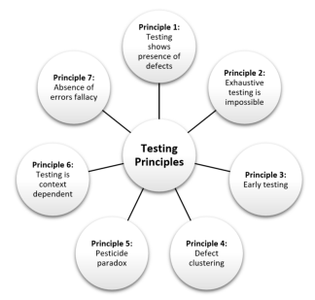

Image source: community.dynamics.com